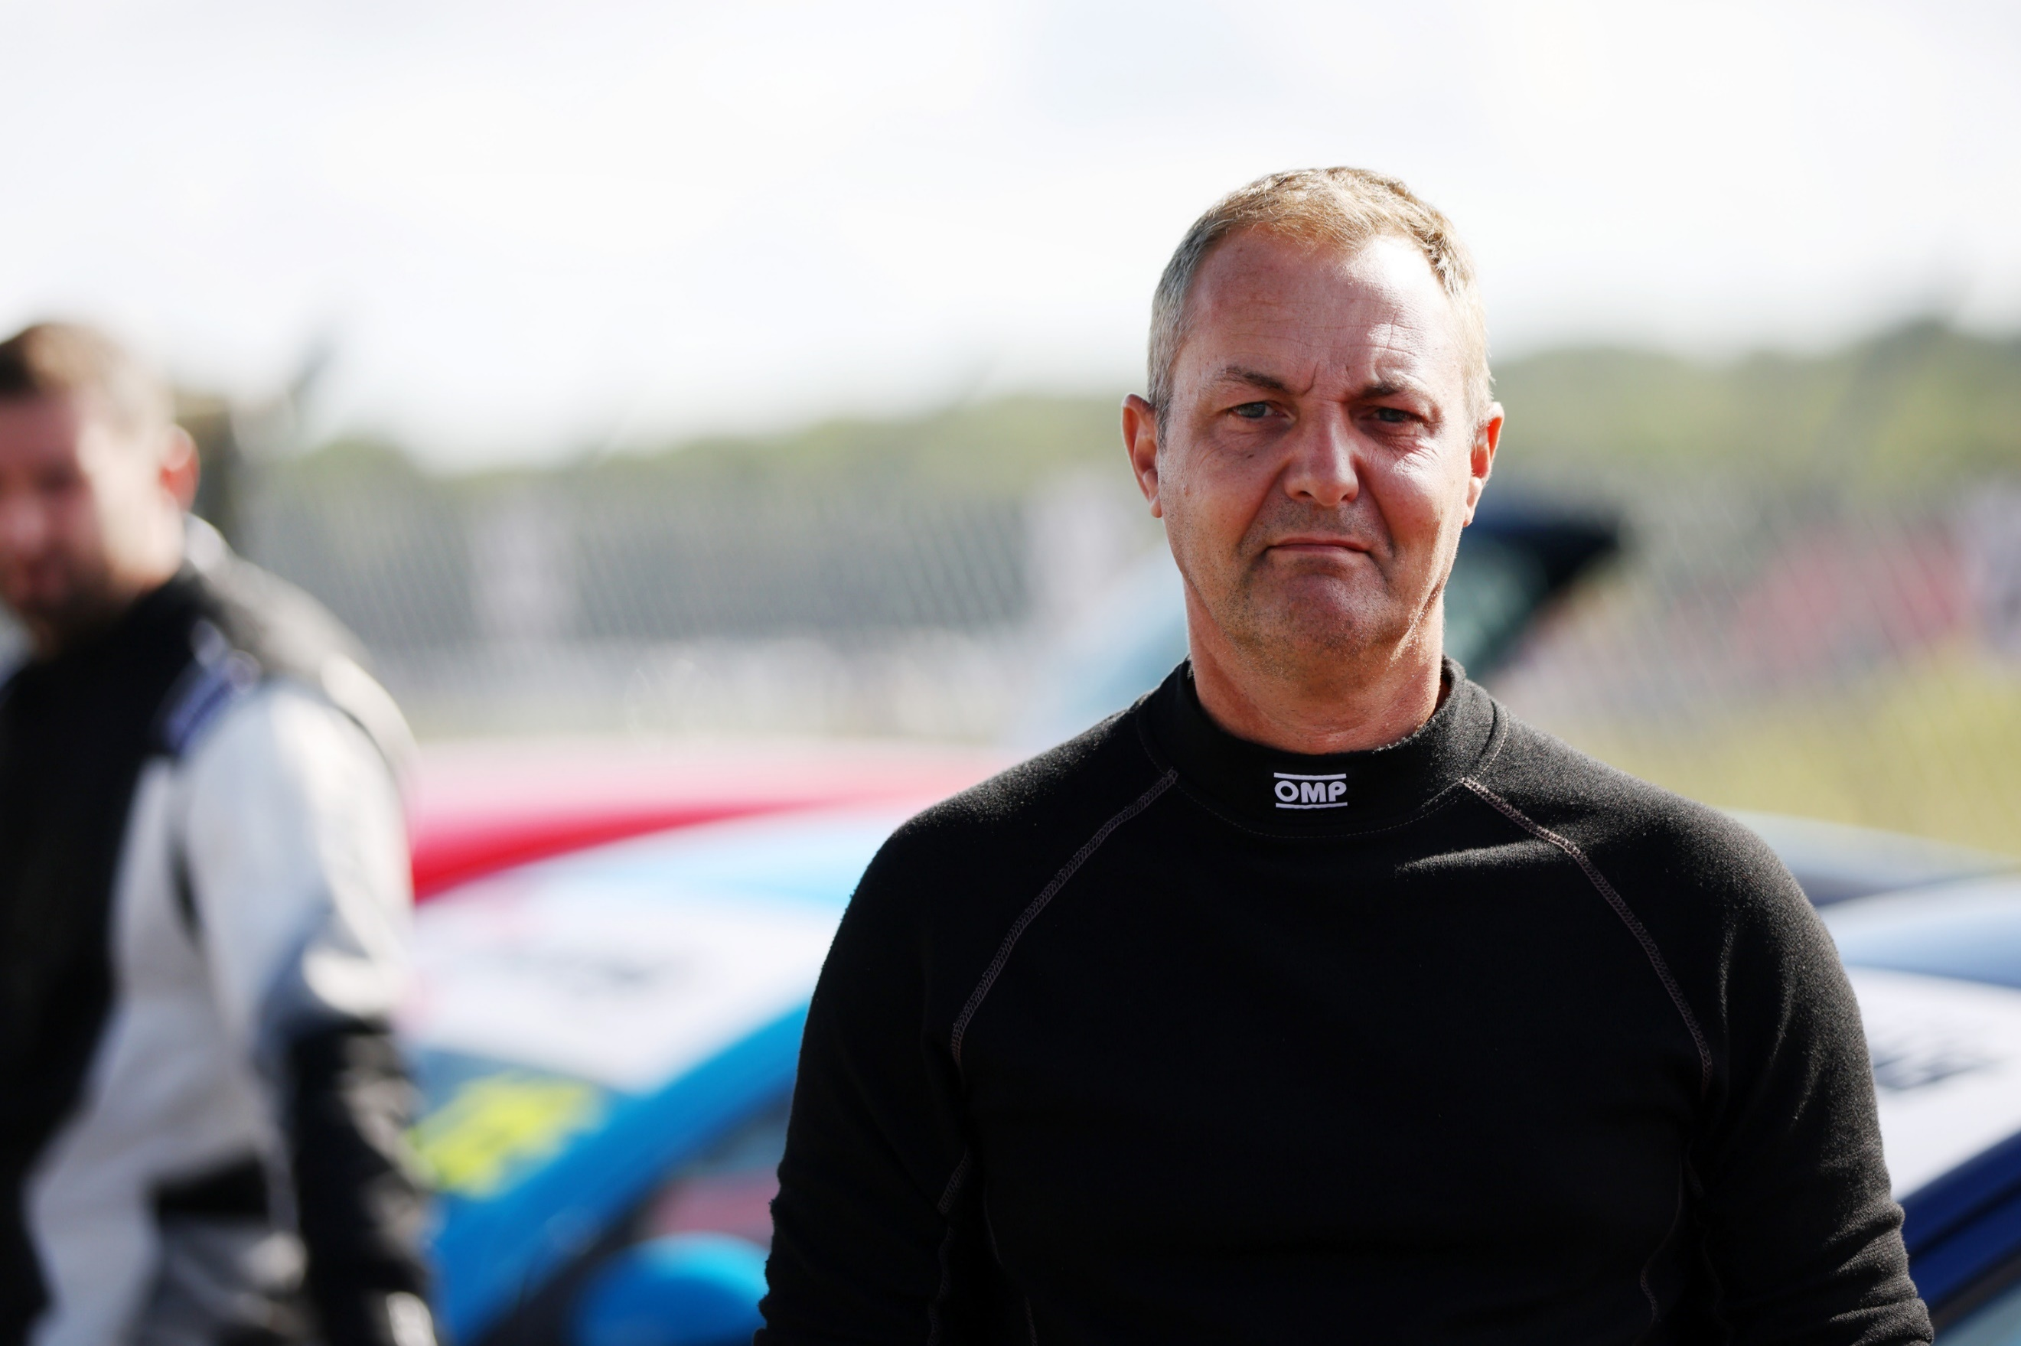 |  | RACING AND INSTRUCTING CV  Racing history  2022 BRSCC City Car Cup  2023 BRSCC City Car Cup  Instructing history  2022-2023 Everyman racing supercar experience day instructor  2023 – present Blendini Motorsport supercar experience day instructor  2023 – present ARDS Instructor – The Motorsports School  I am personable, friendly, and able to put people at ease in a driver situation, to allow them to progress their skills and to offer compentent guidance in a fun manner.  I am flexible on location and can travel to all circuits with ease, and able to take on a variety of roles where needed.  Although I am starting this at a mature age, I am very proficient at my instructing, by keeping customers safe and controlled, as well as being able to push people and get them to trust what the car will do. Racing in the CCC has developed my racecraft skills and taught me how to control and teach how a car will react in various scenarios.  Supercar experience days I instruct skills at developing customers to learn the correct lines, how and when to brake, along with keeping the car balanced, but also to push their limits in a safe and controlled manner. So their experience is the best it can be.  I can present well in a classroom situation as I am fully trained in presenting to large and small audiences.  My current role with The Motorsport School is to asses drivers who are talking their ARDS race licence course to make sure they are competent and to the standard to pass the test.

Andrew Payne
ARDS B Instructor

DOB 15/09/1973

CONTACT
PHONE NUMBER:
07936 594185

EMAIL ADDRESS:
Andrewpayne186@yahoo.com

