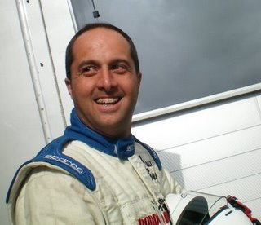

Nationality: Brazilian
Mobile: +44 7782193073
Email: adrianogm@hotmail.com
Website: www.adrianomedeiros.co.uk

Racing CV

2017
Classic Formula Ford 1600 – 2017 Champion
7 victories – 6 poles – 9 fastest laps
Britcar BMW E46 M3

2016
Dubai 24hrs
Britcar – 1 Win
Classic formula Ford 1600 – 2016 Champion
Lotus UK Cup – Driver coaching and racing alongside Axel Van Nederveen – 1 fastest lap

2015
Classic Formula Ford 1600
2 races – 2nd and 10th
Oulton Park Gold Cup at the Jaguar Heritage Championship in a XK120
2013
Classic Formula Ford 1600 Champion
5 wins, 6 fastest laps, 5 poles
Champion of Brands, Formula Ford 1600
1 win in class, plus fastest lap

2012
Euro Nascar (Chevrolet Camaro)
1 win, 1 fastest lap
Silverstone 24 hours (BMW E46) – 13th overall, 7th in class
2011
GT Trophy
3 races (Porsche996 Cup car) 1 Win, 1 fastest lap
Barcelona 24 hours (BMW E36) (car crashed at 3am by the owner
2010
GT Trophy (Porsche 996 Cup car)
2 wins – 2 fastest laps
Speed Series – 6 rounds (Ligier JS49)
best result 4th
2008
Radical UK SR3
complete 10 round championship – highlights of the season include leading the race at Donnington; moving through the field from last to 2nd at Brands; completing the 2nd fastest lap in the European round at Silverstone
2007
Britcar Championship, UK (Porsche 993)
4th in class
2006
FF1600
UK South Midland Championship, with WestTech/John Miller, 6 races: 2nd, 3rd, 3rd, 3rd, dnf, 5th
2005
• Top Gear Live Show – Professional Driver
2004 – current
Professional Driver for Osbourne Purdie Professional driver agency working for VW, Audi, Seat, Skoda, Vauxhall, Mercedes, Toyota, Nissan – as a demonstration /test driver for media launch of new vehicles
2003 – current
Palmersport Motorsport, Senior Racing Driver Instructor
2000
Interlagos 500km (saloons), Vauxhall Cavalier
2nd place
1999 ‐ 2000
Free Force Championship, Sao Paulo
Two 4th places (Chevy Opala)
1998
Super Stock Event, Sao Paulo
Finished 6th in championship (when competing in only 4 out of 11 rounds) best result 2nd (Chevy Opala 4.1)
Further Information
• Occupation: Professional Racing Driver
• ARDS Grade A instructor
• Precision Driver
• Product demonstrator
• Racing Driver Coach
• Hold a MSA International C license

